- Go to myTFC http://my.tfc.edu

- Click on Sign in with Microsoft

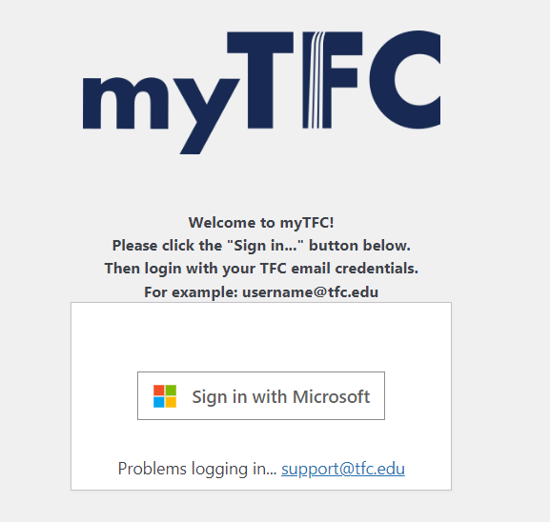

- Enter your TFC email address. (Your full first and last name followed by tfc.edu)
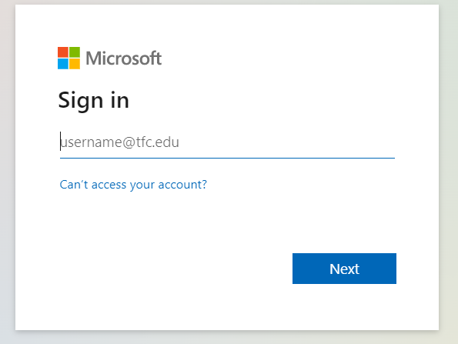
- Enter your password – This is your student ID number followed by TFC Example: (123000TFC) OR (123000TFC!) depending on what your welcome letter from Aimee Womble stated. It may want to send a code to your email or phone.

- Click on the Graduate Studies link on the left side of the screen.



- Click on the words Login in the upper right-hand corner. This will take you to your course pages.


